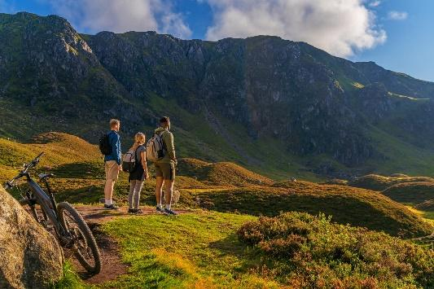

**BikeScotland**

**BikeScotland** is a company with many stores throughout the country selling bikes.

**BikeScotland** stocks racing bikes, mountain bikes and road bikes.

**BikeScotland** would like to have a website developed that will give details of their bestselling bikes. You have been asked to create a 4 page website for **BikeScotland** with a home page, linked to 3 sub-pages for racing bikes, mountain bikes and road bikes.

**Navigation Structure**

**Site Assets**

You will be provided with suitable images and text for each page.

**Implement your site using HTML and CSS**

**HTML**

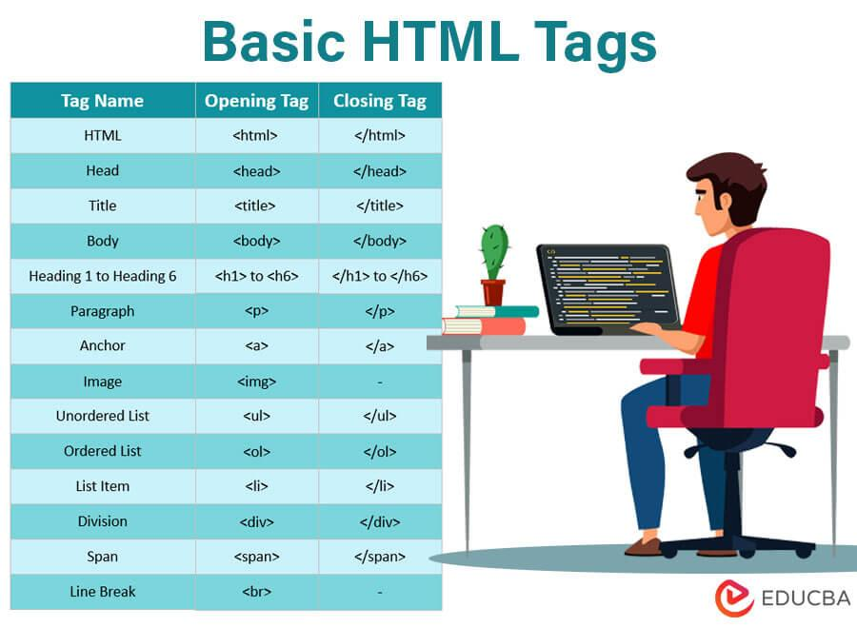

**CSS**

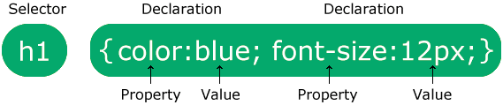

|  |  |
| --- | --- |
| **Software used** |  |
| **Hardware used** |  |
| **File Size** |  |
| **Security Risk** |  |
| **Connectivity** |  |

Name: